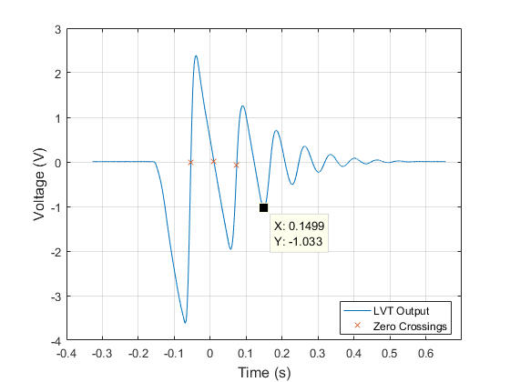

Figure : Plot of LVT measurement voltage vs. time

1. Motion of the mass:

During free fall, the slope of the velocity is linear, indicating there is a constant force acting on it in the negative direction – the force of gravity. The measurements are negative indicating the mass is falling.

During initial impact with the foam, the velocity is still negative but begins to increase towards the positive direction, indicating the foam slows down the mass and slowly accelerates it at constant force (damping force) in the positive y direction.

When the velocity measurement crosses zero the first time at the leftmost labeled X point the mass has reached the bottom of its trajectory inside the foam with maximum elastic potential energy and zero kinetic energy. Therefore, a short while after the X point the mass would bounce off the foam. At that moment, the mass would be travelling in the positive y direction and experience a negative acceleration due to gravity.

1. Physical significance of:
   1. The first three zero crossings are labeled by X in Figure 1. The first zero crossing is when the mass reached the lowest point inside the roam. The second zero crossing is when the mass reached the highest point after first bounce. The third zero crossing is when the mass reached the lowest point (with respect to each cycle) inside the foam.
   2. First minimum voltage point is when the mass about to hit the foam where the gravitational potential energy is entirely converted to kinetic energy (maximum speed). The first maximum voltage point is when the mass reached the damped starting position where the undamped net displacement would be zero and velocity would be maximum.
2. After three free falls, the approximate time when the mass stopped bouncing off the foam is 0.15s. After that point, the negative displacement part of the velocity measurement looked more like a second order damped output.
3. Polyfit of the initial slope gives -47.251 V/s. Gravity: -386 in/sec2:
4. Integrated Position and Velocity:

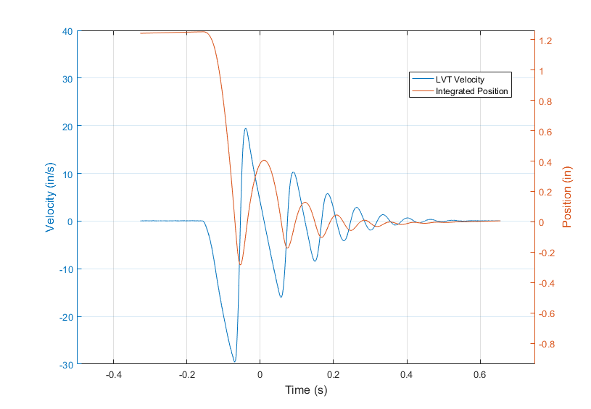

Figure : LVT measurement converted to velocity and integrated to give position

1. Figure 3 shows the damped foam-mass system response. The circle peaks are used to determine the damping ratio and damped natural frequency. The spring constant is found using .

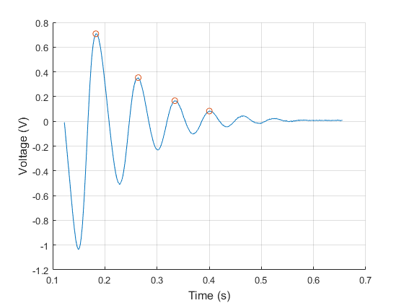

Figure : Damped portion of the foam-mass system

Using damping force formula:

Where is the velocity of the mass upon impact with the foam, which is the velocity at the first minimum peak:

The average force is found to be: -0.2226 lbf